|  |
| --- |
| Second level |
| Hospital database |
| Database project |

|  |
| --- |
| 12-23-2023 |

**Introduction**

Healthcare is changing with new technologies to better care for patients and make hospital operations smoother.

Our Hospital Database Project focuses on improving how a hospital manages its day-to-day activities using a well-designed database system. The goal is to make things like patient records, staff schedules, room and equipment management, and medical diagnoses easier to handle.

**Business Rules:**

* Each patient that is admitted at the hospital must submit their first and last name, age, gender, contact number, personal id, and their address.
* Each Record submitted must contain the id of the record, and the date of admission and the date of discharge.
* Each bill issued contains the bill id, doctor charges and the room charges.
* Each staff member has their own id, first and last name, age, gender, work field, Salary, contact number, and address.
* Each doctor has their own unique id and their specialty.
* Each nurse has their own unique id, and years of experience.
* Each diagnosis must have the disease name and its treatment.
* Each room must have a type, a number, and its status.
* Each piece of equipment must have a name, an id, and its price.
* Each patient must have at least one record, and a record must be owned by one patient.
* A doctor must treat many patients, and a patient must be treated by a doctor.
* A doctor must have their patients’ records, and a record must be given to one doctor.
* A doctor must give at least one diagnosis to the patient, and a diagnosis must be given by a doctor.
* A patient must receive at least one diagnosis, and a diagnosis can be given to many patients.
* A patient must be issued one bill, and a bill must be issued to one patient.
* A room can be assigned to one or more patients, a patient can be assigned one room.
* Equipment must be assigned to at least one room; a room must at least have one piece of equipment.
* Doctors must be a member of the staff, and the staff must contain many doctors.
* Nurses must be a member of the staff, and the staff must contain many nurses.

**ER Diagram**

In a hospital database before the patients there are the staff, so following the business rule we created Staff entity that contains the basic human identifiers (name, age, gender,…etc) , salary, and what do they do(work area).

The foundation of a hospital are the doctors and nurses, and since they both are members of the staff we made a relationship between them and the staff (member of).A doctor and a nurse they both have two id’s one for staff access (it’s ) and their own id’s to allow them access to places that regular staff cant have access to (like a surgery room).

Second comes the rooms of the hospitals and their equipment, so we created their own entities including their attributes.

Third in place come the patients, any patient registering to the hospital must submit their personal data and their id and date of arrival is added to their record and once they get their diagnoses and its treatment from the doctor they submit their date of discharge.

The last thing a patient does is pay the bill that contains the doctors bill, and the room bill if they needed to stay in a room overnight.

**Logical Schema**

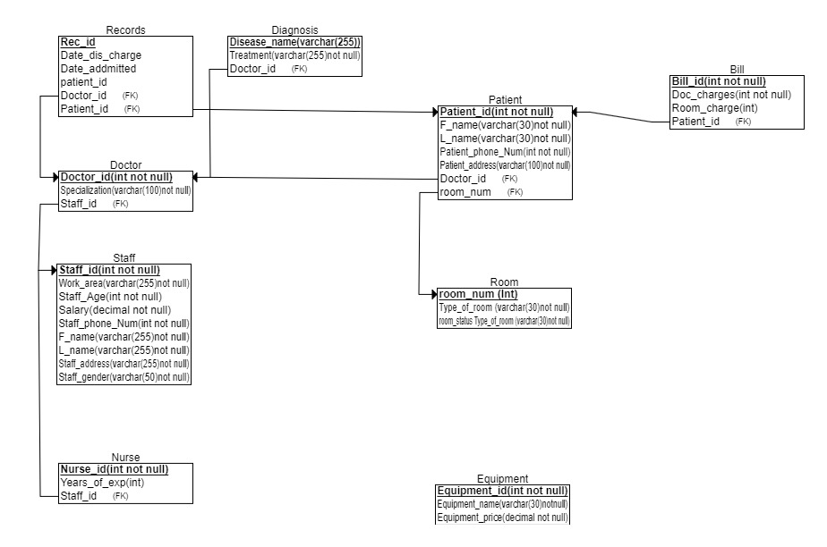Before Normalization

After Normalization:

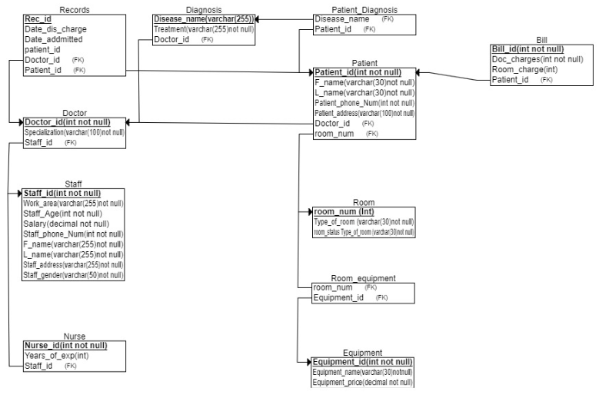

Normalization Explanation:

we separated (Patient Diagnosis from Patient) and

(Room Equipment from Room) because patients and rooms could have multiple values and that violates the 1NF rule that (each piece of data in a record should have one and only one value linked to it), 2NF and 3NF are already achieved because there are no partial dependencies (non-primary key not depending on the primary key) and there are no transitive dependencies (non-primary keys depending on each other).

**CODE**

In the code below we followed the logical schema to create each table adding the constrains and then inserted data to make the tables more clear.

/* The table constraints are: R_num is a primary key, and the rest of the data is not null */

create table Room (

R_num int not null auto_increment primary key,

Tybe_of_room varchar(30) not null,

Room_status varchar(30) not null

);

/* The table constraints are: primary key for Equipment_id and not null for the rest of the attributes */

create table Equipment(

Equipment_name varchar(30) not null,

Equipment_id int not null auto_increment primary key,

Equipment_price decimal not null

);

/* This table is created from the many-to-many relationship between Room and Equipment entities; it contains the constraints of primary and foreign keys */

create table room_equipment(

R_num int not null,

Equipment_id int not null primary key,

foreign key (R_num) references Room(R_num),

foreign key (Equipment_id) references Equipment(Equipment_id)

);

/* The table constraints are: Staff_id is a primary key, and the rest of the attributes cannot be null */

create table Staff (

Staff_id int not null auto_increment primary key,

Work_area varchar(255) not null,

Staff_age int not null,

Salary decimal not null,

Staff_phoneNum int not null,

F_name varchar(255) not null,

L_name varchar(255) not null,

Staff_address varchar(255) not null,

Staff_gender varchar(50) not null

);

/* The table constraints are: Nurse_id is a primary key, and staff_id is a foreign key referencing Staff(Staff_id) */

create table Nurse (

Nurse_id int not null primary key,

staff_id int not null,

years_of_exp int,

foreign key(staff_id) references Staff(Staff_id)

);

/* The table constraints are: D_id is a primary key, and staff_id is a foreign key referencing Staff(Staff_id) */

create table Doctor (

D_id int not null primary key,

staff_id int not null,

specialization varchar(100) not null,

foreign key(staff_id) references Staff(Staff_id)

);

/* The table constraints are: patient_id is a primary key, doctor_id is a foreign key referencing Doctor(D_id), and Room_num is a foreign key referencing Room(R_num) */

create table Patient (

patient_id int not null primary key,

F_name varchar(30) not null,

L_name varchar(30) not null,

P_phoneNumber int not null,

P_address varchar(100) not null,

Room_num int null,

doctor_id int not null,

foreign key(doctor_id) references Doctor(D_id),

foreign key(Room_num) references Room(R_num)

);

/* The table constraints are: Rec_id is a primary key, doctor_id is a foreign key referencing Doctor(D_id), and patient_id is a foreign key referencing Patient(patient_id) */

create table Records (

Rec_id int not null auto_increment primary key,

Date_addmitted date not null,

Date_Discharge date not null,

doctor_id int not null,

patient_id int not null,

foreign key(doctor_id) references Doctor(D_id),

foreign key(patient_id) references Patient(patient_id)

);

/* The table constraints are: D_name is a primary key, and doctor_id is a foreign key referencing Doctor(D_id) */

create table Diagnosis (

D_name varchar(255) primary key,

Treatment varchar(255) not null,

doctor_id int not null,

foreign key(doctor_id) references Doctor(D_id)

);

/* The table constraints are: diagnosis_name is a foreign key referencing Diagnosis(D_name), and patient_id is a foreign key referencing Patient(patient_id) */

create table Patient_Diagnosis (

diagnosis_name varchar(255) not null,

patient_id int not null,

foreign key (diagnosis_name) references Diagnosis(D_name),

foreign key(patient_id) references Patient(patient_id)

);

/* The table constraints are: B_id is a primary key, and patient_id is a foreign key referencing Patient(patient_id) */

create table Bill (

B_id int not null auto_increment primary key,

Doc_charges int not null,

Room_charge int ,

patient_id int not null,

foreign key(patient_id) references Patient(patient_id)

);INSERT INTO Room (Tybe_of_room , Room_status) VALUES

('Patient room','good'),

('Operation room','good'),

('Pharmacy','good'),

('Laboratory','under preparation'),

('ICU','good'),

('Radiology room', 'under preparation' ),

('Operation room', 'good'),

('Patient room', 'good'),

('Operation room','underpreparation'),

('Pediatric room','good');

INSERT INTO Equipment (Equipment_name, Equipment_price) VALUES

('X-Ray Machine', 50000.00),

('MRI Scanner', 75000.00),

('ECG Machine', 15000.00),

('Ultrasound System', 30000.00),

('Anesthesia Machine', 20000.00),

('Surgical Instruments Set', 12000.00),

('Hospital Bed', 8000.00),

('Patient Monitor', 18000.00),

('Laboratory Microscope', 5000.00),

('Wheelchair', 300.00);

INSERT INTO room_equipment (R_num, Equipment_id) VALUES

(1, 1),

(2, 2),

(3, 3),

(4, 4),

(5, 5),

(6, 6),

(7, 7),

(8, 8),

(9, 9),

(10, 10);

INSERT INTO Staff (work_area, Staff_age, salary, Staff_phoneNum, F_name,L_name, Staff_address, staff_gender ) VALUES

('Nurse', 35, 3000, 01123456789, 'Mohamed', 'Ali', 'Cairo', 'male'),

('Doctor', 40, 3500, 01234567890, 'Sara', 'Ahmed', 'Alexandria', 'female'),

('IT', 55, 4000, 01012345678, 'Amr', 'Mahmoud', 'Luxor', 'male'),

('Cleaning Staff', 43, 4500, 01123456780, 'Nada', 'Hassan', 'Aswan', 'female'),

('Doctor', 30, 5000, 01234567891, 'Khaled', 'Ibrahim', 'Hurghada', 'male'),

('Nurse', 44, 5500, 01012345679, 'Amina', 'Abdelaziz', 'Sharm El Sheikh', 'female'),

('Cleaning Staff', 48, 6000, 01123456781, 'Hassan', 'Ali', 'Mansoura', 'male'),

('IT', 55, 2500, 01234567892, 'Lina', 'Ahmed', 'Tanta', 'female'),

('Nurse', 33, 2000, 01012345680, 'Ahmed', 'Mohamed', 'Port Said', 'male'),

('Doctor', 32, 1500, 01123456782, 'Mona', 'Samir', 'Suez', 'female');

INSERT INTO Nurse (Nurse_id, staff_id,years_of_exp) VALUES

(35,1,3),

(40,6,5),

(42,9,10);

INSERT INTO Doctor (D_id , specialization,staff_id)

VALUES

(22102, 'Dermatology',2),

(22103, 'Pediatrics',5),

(22104, 'Neurology',10);

INSERT INTO patient (patient_id, F_name,L_name, P_phoneNumber, P_address, Room_num, doctor_id )

VALUES

(21,'Ahmed', 'Ali', 01123456789, 'Cairo',1, 22102),

(22,'Fatima', 'Mohamed', 01234567890, 'Alexandria',1, 22102),

(23,'Omar' , 'Mahmoud', 01012345678, 'Luxor', 1, 22103),

(24,'Nadia', 'Hassan', 01123456780, 'Aswan', 8, 22104),

(25,'Khaled', 'Ibrahim', 01234567891, 'Hurghada',5, 22102),

(26,'Amina', 'Abdelaziz', 01012345679, 'Sharm El Sheikh',8, 22103),

(27,'Ali', 'Hassan', 01123456781, 'asuit', 1,22103),

(28,'Noura', 'Ahmed', 01234567892, 'kafr el sheikh', 8, 22102),

(29,'Mahmoud', 'Mohamed', 01012345680, 'Port Said', 9, 22104),

(30,'Laila', 'Samir', 01123456782, 'Suez', 10, 22104);

INSERT INTO Records (Date_addmitted, Date_Discharge, patient_id, doctor_id)

VALUES

('2000-01-02', '2000-04-02', 21, 22102),

('2001-02-02', '2001-08-02', 22, 22102),

('2000-12-07', '2001-05-02', 23, 22103),

('2004-06-05', '2004-09-02', 24, 22104),

('2006-04-02', '2006-05-02', 25, 22102),

('2002-01-01', '2002-02-02', 26, 22104),

('2020-10-02', '2020-11-06', 27, 22103),

('2000-01-09', '2000-07-02', 28, 22103),

('2002-11-08', '2002-01-01', 29, 22102),

('2003-04-06', '2003-10-02', 30, 22104);

INSERT INTO diagnosis (D_name, treatment, doctor_id) VALUES

('Flu', 'was advised pain relivers and physical therapy', 22102),

('Hypertension', 'Medications', 22102),

('Diabetes', 'was advised Insulin and oral medications', 22103),

('Migraine', 'was advised complete rest and pain killers', 22104),

('Arthritis', 'was advised physical therapy and joint replacement', 22102),

('Asthma', 'was advised Bronchodilators,', 22103),

('Depression', 'was advised Psychotherapy medications', 22104),

('Cancer', 'was advised to prpceed with surgery and chemotherapy', 22104),

('Osteoporosis', 'was advised Calcium supplements and vitamin D', 22102),

('Heart Disease', 'was advised Medications and lifestyle changes', 22103);

INSERT INTO patient_diagnosis (diagnosis_name,patient_id)

VALUES

('Flu', 21),

('Hypertension', 22),

('Diabetes', 23),

('Migraine', 24),

('Arthritis', 25),

('Asthma', 26),

('Depression', 27),

('Cancer', 28),

('Osteoporosis', 29),

('Osteoporosis', 30);

INSERT INTO Bill (B_id, Doc_charges,Room_charge,patient_id )

VALUES (31, 2, 5, 21),

(32, 4, 6, 22),

(33, 7, 8, 23),

(34, 2, 4, 24),

(35, 12, 5, 25),

(36, 5, 5, 26),

(37, 3, 6, 27),

(38, 8, 2, 28),

(39, 5, 5, 29),

(30, 8, 8, 30);

Select * from staff;

Select * from room;

Select * from records;

Select * from patient_diagnosis;

Select * from patient;

Select * from nurse;

Select * from doctor;

Select * from bill;

Select * from diagnosis;

Select * from Equipment;

Select * from room_equipment;

This is an example of when tables need to be normalized, our database didn’t need much normalization, so we are using fake data to explain the rules of the 3 forms of normalization and their applications in a data that would need one.

To convert 1NF we need to fix repeated values (diagnosis and specialization)

Diagnosis as 1NF: Specialization as 1NF:

To convert to 2NF the tables need to be in 1NF form, eliminate partial dependencies so that all keys depend on the primary key.

Partial Dependencies:

* In the Patient’s Table, Patient ID and PatientName together determine the Diagnosis (Diagnosis dependent on ID and Name).
* In the Doctors Table, DoctorID and DoctorName together determine the Specialization (Specialization dependent on ID and Name).

To convert to 2NF 2 new tables were made to separate related data to into different tables:

To convert to 3NF the tables need to be in 2NF form and not have Transitive dependencies (non-primary keys depending on each other)

The Tables are 3NF and don’t need further change because every key in each table depend on its respective primary key and not on other non-primary keys.

Tables before normalization:

* Patients
* Doctors
* Appointments

Tables after normalization:

* Patients (PatientID, PatientName, PatientDiagnosis)
* Doctors (DoctorID, DoctorName, Specializations)
* Appointments (AppointmentID, AppointmentDate, PatientID, DoctorID)
* Specializations (Specialization, DoctorID)
* Patient Diagnosis (PatientDiagnosisID, PatientID)